http://www.wcftutorial.net/Home.aspx

Address
Basically URL, specifies where this WCF service is hosted .Client will use this url to connect to the service. e.g
http://localhost:8090/MyService/SimpleCalculator.svc

Binding
Binding will describes how client will communicate with service.
A binding has several characteristics, including the following:
- Transport -Defines the base protocol to be used like HTTP, Named Pipes, TCP, and MSMQ are some type of protocols.
- Encoding (Optional) - Three types of encoding are available-Text, Binary, or Message Transmission Optimization Mechanism (MTOM). MTOM is an interoperable message format that allows the effective transmission of attachments or large messages (greater than 64K).
- Protocol(Optional) - Defines information to be used in the binding such as Security, transaction or reliable messaging capability

Contract
Collection of operation that specifies what the endpoint will communicate with outside world. Usually name of the Interface will be mentioned in the Contract
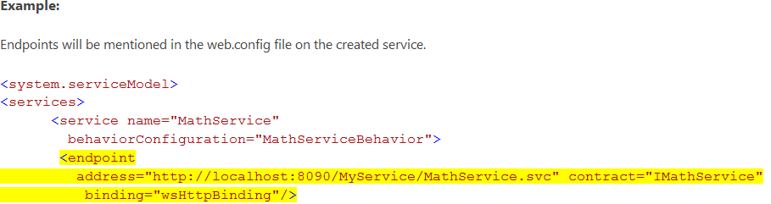

I am creating a service that has to be used by two type of client. One of the client will access SOAP using http and other client will access Binary using TCP. How it can be done? With Web service it is very difficult to achieve, but in WCF its just we need to add extra endpoint in the configuration file.

Data contracts are used to define the data structure. Messages that are simply a .NET type, lets say in form of POCO (plain old CLR object), and generate the XML for the data you want to pass.
Message contracts are preferred only when there is a need to “control” the layout of your message(the SOAP message); for instance, adding specific headers/footer/etc to a message.
easy to use way to customize your SOAP messages both for security concerns and to conform to various interoperability standards
For instance, session or correlation information can be passed in headers, rather than adding additional parameters to operations or adding this information as fields in the data itself.
Another example is security, where you may want to implement a custom security protocol (bypassing WS-Security) and pass credentials or tokens in custom SOAP headers.
Unless you have a need to define what goes in a message body and what goes in a header, you’re OK sticking with Data Contracts.

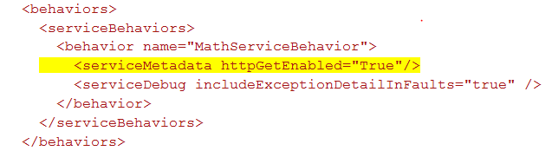
Publish metadata by specifying behaviour,

Service Host object is in the process of hosting the WCF service and registering endpoints. It loads the service configuration endpoints, apply the settings and start the listeners to handle the incoming request.

Channels:
Channels are the core abstraction for sending message to and receiving message from an Endpoint. Broadly we can categories channels as

Transport Channels
- Handles sending and receiving message from network. Protocols like HTTP, TCP name pipes and MSMQ.

Protocol Channels
- Implements SOAP based protocol by processing and possibly modifying message. e.g. WS-Security and WS-Reliability.

To create a client application for a WCF service requires the following steps
Get the Proxy class and service end point information Using SvcUtil.exe
Call operations.
After using the object created in the above steps, we have to dispose the object. Channel will be closed with the service, when the object is cleared.
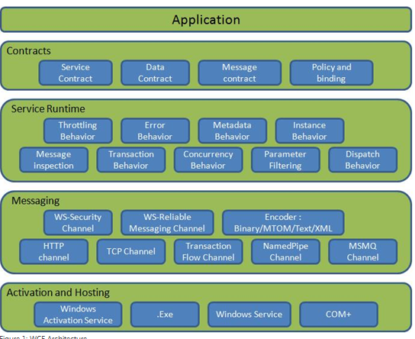
Policies and Binding
- Specify conditions required to communicate with a service e.g security requirement to communicate with service, protocol and encoding used for binding.

Service Runtime
- It contains the behaviors that occur during runtime of service.

Throttling Behavior- Controls how many messages are processed.
Error Behavior - Specifies what occurs, when internal error occurs on the service.
Metadata Behavior - Tells how and whether metadata is available to outside world.
Instance Behavior - Specifies how many instance of the service has to be created while running.
Transaction Behavior - Enables the rollback of transacted operations if a failure occurs.
Dispatch Behavior - Controls how a message is processed by the WCF Infrastructure.
Messaging
- Messaging layer is composed of channels. A channel is a component that processes a message in some way, for example, by authenticating a message. A set of channels is also known as a channel stack. Channels are the core abstraction for sending message to and receiving message from an Endpoint. Broadly we can categories channels as

Transport Channels
Handles sending and receiving message from network. Protocols like HTTP, TCP, name pipes and MSMQ.

Protocol Channels
Implements SOAP based protocol by processing and possibly modifying message. E.g. WS-Security and WS-Reliability.

Activation and Hosting
- Services can be hosted or executed, so that it will be available to everyone accessing from the client. WCF service can be hosted by following mechanism

IIS
Internet information Service provides number of advantages if a Service uses Http as protocol. It does not require Host code to activate the service, it automatically activates service code.

Windows Activation Service
(WAS) is the new process activation mechanism that ships with IIS 7.0. In addition to HTTP based communication, WCF can also use WAS to provide message-based activation over other protocols, such as TCP and named pipes.

Self-Hosting
WCF service can be self hosted as console application, Win Forms or WPF application with graphical UI.

Windows Service
WCF can also be hosted as a Windows Service, so that it is under control of the Service Control Manager (SCM).

Characteristics of the service are described by the metadata. This metadata can be exposed to the client to understand the communication with service. Metadata can be set in the service by enabling the ServiceMetadata node inside the servcieBehaviour node of the service configuration file.

Per-Call Service
When WCF service is configured for Per-Call instance mode, Service instance will be created for each client request. This Service instance will be disposed after response is sent back to client.

Per-Session Service
When WCF service is configured for Per-Session instance mode, logical session between client and service will be maintained. When the client creates new proxy to particular service instance, a dedicated service instance will be provided to the client. It is independent of all other instance.

Singleton Service
When WCF service is configured for Singleton instance mode, all clients are independently connected to the same single instance. This singleton instance will be created when service is hosted and, it is disposed when host shuts down.
When to Use:
Per call
- You want a stateless services.
- Your service holds intensive resources like connection objects and huge memory objects.
- Scalability is a prime requirement. You would like to have a scaled out architecture.
- Your WCF functions are called in a single threaded model.

Per session
- You want to maintain states between WCF calls.
- You a scaled up architecture.
- Light resource references.

Single
- You want share global data through your WCF service.
- Scalability is not a concern.

http://webcache.googleusercontent.com/search?q=cache:K40wwMxQY7QJ:http://agkumardotnetfunda.blogspot.com/2011/10/instance-management-in-wcf-oct-12-2011.html%2Bwhen+to+use+Instance+Deactivation+wcf&oe=utf-8&rls=org.mozilla%3Aen-US%3Aofficial&client=firefox-a&gs_l=heirloom-serp.3...2595958.2605554.0.2605983.33.32.0.1.1.1.379.5710.10j12j2j8.32.0...0.0...1c.1.7BQu0YeKeT4&hl=en&ct=clnk

What is Instance Deactivation in WCF ?
The sessionful service instance management technique connects a client (or clients) to a service instance.As we know that each service instance is hosted in a context. When the session starts, the host creates a new context and when the session ends, the context is terminated. By default, the lifetime of the context is the same as that of the instance it hosts. However, for optimization purposes, WCF provides the service designer with the option of separating the two lifetimes and deactivating the instance separately from its context. In fact, WCF also allows the situation of a context that has no instance at all. This instance management technique context is called Instance Deactivation. The common way of controlling context deactivation is via the ReleaseInstanceMode property of the (refer to above link).
Note :- Instance deactivation is an optimization technique, and like all such optimization techniques, you should avoid it in the general case. Consider using instance deactivation only after failing to meet both your performance and scalability goals and when careful examination and profiling has proven beyond a doubt that using instance deactivation will improve the situation. If scalability and throughput are your concern, you should take advantage of the simplicity of the per-call instancing mode, and avoid instance deactivation.

http://wcftutorial.net/WCF-Instance-Deactivation.aspx

There are three way of communication between source and destination
- Simplex - It is one way communication. Source will send message to target, but target will not respond to the message.
- Request/Replay - It is two way communications, when source send message to the target, it will resend response message to the source. But at a time only one can send a message
- Duplex - It is two way communication, both source and target can send and receive message simultaniouly.

Durable Service
Durable services are WCF services that persist service state information even after service host is restarted or Client. It means that durable services have the capability to restore their own state when they are recycled. It can use data store like SQL database for maintain instance state. It is new feature in .Net 3.5
You might think that we can also maintain session using WCF sessions, but content in the session environment is not persisted by default. If the service is shut down or client closes the proxy, data will be lost. But in case of Durable service it is still maintained.
Working:
When Durable service is created with database as data store, it will maintain all its state information in the table.When a client make a request to the service, instance of the service is serialized, a new GUID is generated. This serialized instance xml and key will be saved in the database. We will call this GUID as instanceID. Service will send the instanceID to the client, so later it can use this id to get the instance state back. Even when client is shut down, instanceId will be saved at the client side. So when ever client opening the proxy, it can get back the previous state.

What is Channel Factory :
http://www.sujitbhujbal.com/2012/03/difference-between-proxy-and-channel.html
http://msdn.microsoft.com/en-us/library/ms734681.aspx

The generic ChannelFactory class is used in advanced scenarios that require the creation of a channel factory that can be used to create more than one channel.
Use ChannelFactory with a known interface. This relies on you having local interfaces that describe the service (the service contract). The big advantage is that can manage change much more easily - you still have to recompile and fix changes, but now you're not regenerating code, you're referencing the new interfaces. Commonly this is used when you control both server and client as both can be much more easily mocked for unit testing
In order to use ChannelFactory<T> you must be willing to share contract assemblies between the service and the client. If this is okay with you then ChannelFactory<T> can save you some time.
When you share a common service contract dll between the client and the server, you'll be using the ChannelFactory class
When we use channel factory following steps to do
- Create a binding
- Create a ChannelFactory.
- Create a Channel
- Send/Receive messages over that channel.

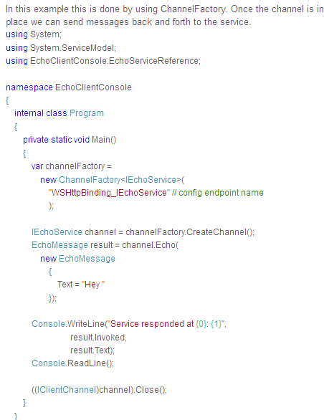
Increasing Middle-Tier Client Performance
Compared to previous communications technologies, such as Web services using ASP.NET, the creation of a WCF client instance can be more complex due to the rich feature set of WCF. For example, when a ChannelFactory object is opened it can establish a secure session with the service, a procedure that increases the startup time for the client instance. Typically, these additional feature capabilities do not affect client applications greatly since the WCF client makes several calls, and then closes.
Middle-tier client applications, however, can create many WCF client objects quickly and, as a result, experience increased initialization requirements. There are two main approaches to increasing the performance of middle-tier applications when calling services:
- Cache the WCF client object and reuse it for subsequent calls where possible.
- Create a ChannelFactory object and then use that object to create new WCF client channel objects for each call.
http://msdn.microsoft.com/en-us/library/aa738757.aspx

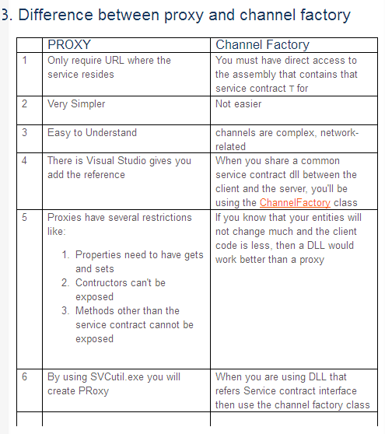

At the company I work for, we have been using WCF for over a year now, and one of the things we have discovered is that the code in the system generated proxies is frequently hideous, sometimes doesn’t build, and the config files it generates are truly hideous. We ended up doing something similar to the third option I present below.
- VS Generated Proxy
- svcutil Proxy (to be used in scenarios where express edition is used for development)
- Proxy by hand
http://www.codeproject.com/Articles/33297/WCF-Proxy-Generation-Options

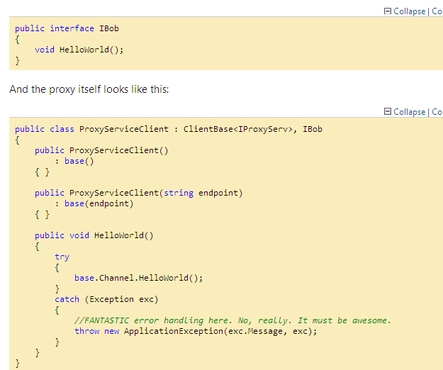

When you set aspNetCompatibilityEnabled to true in your config file, you are stating that your services will participate in the ASP.NET pipeline; so items like ASP.NET session are available. You need to decorate your services appropriately if this is the case, since ASP.NET Compatibility Mode is set to false by default.
So by decorating your service implementation with a RequirementsMode of Allowed, you're stating a happy middle ground that basically says your service doesn't care what the aspNetCompatibility mode is (true or false). If your RequirementsMode is Required, then you need to have the config aspNetCompatibilityEnabled set to true; the opposite is true if your RequirementsMode is set to NotAllowed.
(If you go with the happy middle ground of RequirementsMode of Allowed, you can check in your service implementation if aspNetCompatibilityEnabled is enabled or not by checking the static ServiceHostingEnvironment.AspNetCompatibilityEnabled property.)
This mode requires that the bindings use the HTTP transport and the service itself must be hosted in IIS.

